Scikit-learn/ Sklearn Objects – fit() vs transform() vs fit_transform() vs predict()

Sklearn Objects
Primarily, there are three types of objects in scikit-learn design:
1. Estimator
2. Predictor
3. Transformer
Now, Let’s see the usage of some important methods fit(), transform(), fit_transform() and predict().

Estimators
fit()
– It is used for calculating the initial parameters on the training data and later saves them as internal objects state.
– This method calculates the parameters μ(mean) and σ(standard deviation) and saves them as internal objects.
– A black box which only does the computation and gives nothing.

Transformers
transform()
– Use the initial above calculated values and return modified training data as output.
– Using these same parameters, using this method we can transform a particular dataset.
– Used for pre-processing before modeling.
fit_transform()
– It is a conglomerate above two steps. Internally, it first calls fit() and then transform() on the same data.
– It joins the fit() and transform() method for the transformation of the dataset.
– It is used on the training data so that we can scale the training data and also learn the scaling parameters. Here, the model built will learn the mean and variance of the features of the training set. These learned parameters are then further used to scale our test data.

Predictors
fit()
– It calculates the parameters or weights on the training data (e.g. parameters returned by coef() in case of Linear Regression) and saves them as an internal object state.
predict()
– Use the above-calculated weights on the test data to make the predictions.

Difference between fit(), transform(), and fit_transform() methods in scikit-learn
Let’s try to understand the difference with a given example:
Suppose you have an array arr = [1,2,3,y,5] and you have a sklearn class FillMyArray that filled your array.
When you declare an instance of your class:
my_filler = FillMyArray()
We have the in hand methods fit(), transform() and fit_transform().
fit(): my_filler.fit(arr) will compute the value to assign to x to fill out the array and store it in our instance my_filler.
transform(): After the value is computed and stored during the previous .fit() stage we can call my_filler.transform(arr) which will return the filled array [1,2,3,4,5].
fit_transform(): If we perform my_filler.fit_transform(arr) we can skip one line of code and have the value calculated along with assigned to the filled array that is directly returned in only one stage.

Let’s answer a crucial question
Question: We are aware that we call fit_transform() on our training dataset, while the transform() method on our test dataset. But the question is why do we do so?
The real deal here is “Data leakage”.
fit_transform do certain calculations followed by transformation, Let’s assume calculating the mean or average of columns from certain data and then replacing the missing values according to it. For a training set, we need to both calculate followed by transformation.
However, for the testing set, Machine learning applies predictions based on the learning during the training set, due to which it doesn’t need to perform calculations and perform just the transformation.
If we perform the fit() method even on test data, we will compute a new mean and variance that will be a Naive scale for each feature and will allow the model to learn on the test data too. However, we will no longer be able to keep it as a surprise to our model and it wouldn’t be able to give us a good estimate on model performance on the unseen data, which is certainly our ultimate aim.
It is the general procedure to scale the data when building a machine learning model. So that the model is not biased to a specific feature and prevents our model to learn the trends of our test data at the same time.

Implementation in Python
Here we try to implement all the functions which we studied in the above part of the article.
Step-1: Import necessary python libraries and then read and load the “TITANIC” Dataset.
import pandas as pd
df=pd.read_csv('titanic.csv', usecols=['Pclass','Age','Fare','Survived'])
df.head()
Step-2: Calculate the number of missing values per column.
df.isnull().sum()
Step-3: Fill the missing value of the “Age” column with their respective median.
df['Age'].fillna(df.Age.median(),inplace=True)
Step-4: Now, again check if there are missing values present or not in any column.
df.isnull().sum()
Step-5: Define our Independent(predictor) and Dependent(response) variables.
X=df.iloc[:,1:]
y=df.iloc[:,0]
Step-6: Split our dataset into train and test subsets.
from sklearn.model_selection import train_test_split
X_train,X_test,y_train,y_test=train_test_split(X,y,test_size=0.20,random_state=42)
Step-7: Now using standard scaler we first fit and then transform our dataset.
from sklearn.preprocessing import StandardScaler
scaler=StandardScaler()
X_train_fit=scaler.fit(X_train)
X_train_scaled=scaler.transform(X_train)
pd.DataFrame(X_train_scaled)
Step-8: Use fit_transform() function directly and verify the results.
X_train_scaled=scaler.fit_transform(X_train)
pd.DataFrame(X_train_scaled)
Step-9: Transform our test data.
X_test_scaled=scaler.transform(X_test)
pd.DataFrame(X_test_scaled)

Conclusion
– Here we observe that the fit_transform() function gives the same result as the function fit() and the transform() function gives separately by combining the results.
– Remember fit_transform() function only acts on training data, transform() acts on test data, and predict() acts on test data.
– In summary, fit() performs or completes the training step, transform() changes the data in the pipeline to pass it on to the next stage in the pipeline, and fit_transform() does both the fitting and the transforming in one possibly short step.

r2_score meaning:-

r2 = r2_score(y, f) print ( 'r2 score for a model which predicts mean value always is' , r2) Output: r2 score for a model which predicts mean value always is 0.0. Code 3: ### Assume y is the actual value and f is the predicted values.

What is Cook’s Distance?
Cook’s distance, Di, is used in Regression Analysis to find influential outliers in a set of predictor variables. In other words, it’s a way to identify points that negatively affect your regression model. The measurement is a combination of each observation’s leverage and residual values; the higher the leverage and residuals, the higher the Cook’s distance.
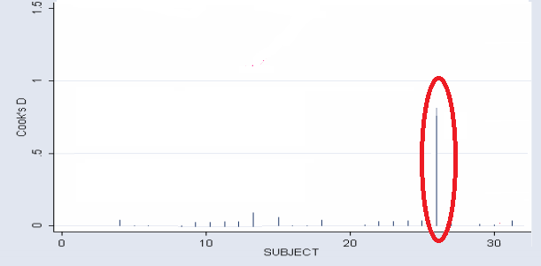
Cook’s distance showing item #26 as a potential outlier.

Several interpretations for Cook’s distance exist. There isn’t a universally accepted rule for cut off points.
- One interpretation is to investigate any point over 4/n, where n is the number of observations.
- Other authors suggest that any “large” Di should be investigated. How large is “too large”? The consensus seems to be that a Di value of more that 1 indicates an influential value, but you may want to look at values above 0.5. Any value that sticks out from the other (like the one in the above chart) should also be investigated.
- An alternative (but slightly more technical) way to interpret Di is to find the potential outlier’s percentile value using the F-distribution. A percentile of over 50 indicates a highly influential point.
If you have a lot of points with large Di values, that could indicate a problem with your regression model in general.

Formula
Technically, Cook’s D is calculated by removing the ith data point from the model and recalculating the regression. It summarizes how much all the values in the regression model change when the ith observation is removed. The formula for Cook’s distance is:
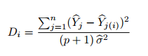
As this can get quite cumbersome by hand, you’ll want to use software like Minitab or SPSS to do it.
In Minitab:
- Go to Regression > Regression.
- Click “Storage” then select “Cook’s Distance.”
- Click “OK.”
A COOK column will appear in your data cells with the Cook’s D values.

Leverage Value:

High Leverage Point: A data point is considered to be a High Leverage Point if it has extreme predictor input value. An extreme input value simply means extremely low or extremely high value as compared to other data points in the entire Data set. The reason it is such an import concept in machine learning because it may highly influence your model fit on a particular data.
model fit on a particular data.
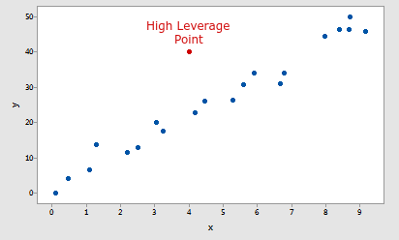
Example of a High Leverage Point

#########################################################################

Distinction Between Outliers and High Leverage Observations

In this section, we learn the distinction between outliers and high leverage observations. In short:
- An outlier is a data point whose response y does not follow the general trend of the rest of the data.
- A data point has high leverage if it has "extreme" predictor x values. With a single predictor, an extreme x value is simply one that is particularly high or low. With multiple predictors, extreme x values may be particularly high or low for one or more predictors, or may be "unusual" combinations of predictor values (e.g., with two predictors that are positively correlated, an unusual combination of predictor values might be a high value of one predictor paired with a low value of the other predictor).
Note that — for our purposes — we consider a data point to be an outlier only if it is extreme with respect to the other y values, not the x values.
A data point is influential if it unduly influences any part of a regression analysis, such as the predicted responses, the estimated slope coefficients, or the hypothesis test results. Outliers and high leverage data points have the potential to be influential, but we generally have to investigate further to determine whether or not they are actually influential.
One advantage of the case in which we have only one predictor is that we can look at simple scatter plots in order to identify any outliers and high levrage data points. Let's take a look at a few examples that should help to clarify the distinction between the two types of extreme values.

Example #1
Based on the definitions above, do you think the following data set (influence1.txt) contains any outliers? Or, any high leverage data points?
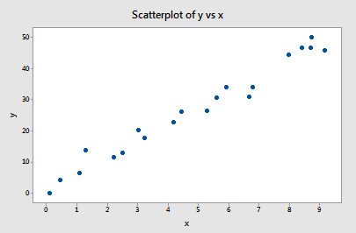
You got it! All of the data points follow the general trend of the rest of the data, so there are no outliers (in the y direction). And, none of the data points are extreme with respect to x, so there are no high leverage points. Overall, none of the data points would appear to be influential with respect to the location of the best fitting line.

Example #2
Now, how about this example? Do you think the following data set (influence2.txt) contains any outliers? Or, any high leverage data points?
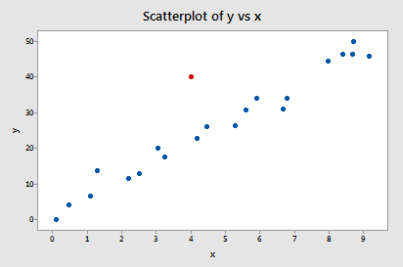
Of course! Because the red data point does not follow the general trend of the rest of the data, it would be considered an outlier. However, this point does not have an extreme x value, so it does not have high leverage. Is the red data point influential? An easy way to determine if the data point is influential is to find the best fitting line twice — once with the red data point included and once with the red data point excluded. The following plot illustrates the two best fitting lines:
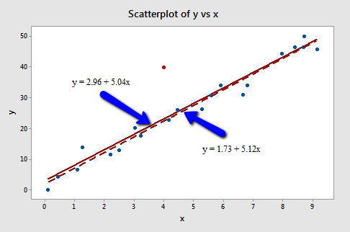
Wow — it's hard to even tell the two estimated regression equations apart! The solid line represents the estimated regression equation with the red data point included, while the dashed line represents the estimated regression equation with the red data point taken excluded. The slopes of the two lines are very similar — 5.04 and 5.12, respectively.
Do the two samples yield different results when testing H0: β1 = 0? Well, we obtain the following output when the red data point is included:
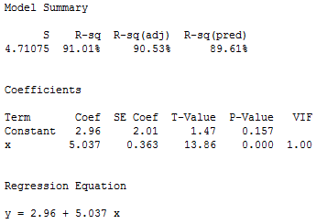
and the following output when the red data point is excluded:
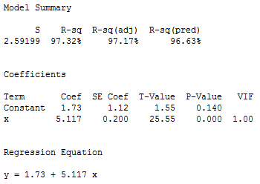
There certainly are some minor side effects of including the red data point, but none too serious:
- The R2 value has decreased slightly, but the relationship between y and x would still be deemed strong.
- The standard error of b1, which is used in calculating our confidence interval for β1, is larger when the red data point is included, thereby increasing the width of our confidence interval. You may recall that the standard error of b1 depends on the mean squared error MSE, which quantifies the difference between the observed and predicted responses. It is because the red data point is an outlier — in the y direction — that the standard error of b1 increases, not because the data point is influential in any way.
- In each case, the P-value for testing H0: β1 = 0 is less than 0.001. In either case, we can conclude that there is sufficient evidence at the 0.05 level to conclude that, in the population, x is related to y.
In short, the predicted responses, estimated slope coefficients, and hypothesis test results are not affected by the inclusion of the red data point. Therefore, the data point is not deemed influential. In summary, the red data point is not influential and does not have high leverage, but it is an outlier.

Example #3
Now, how about this example? Do you think the following data set (influence3.txt) contains any outliers? Or, any high leverage data points?
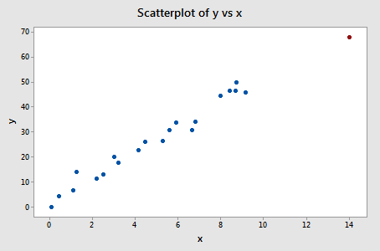
In this case, the red data point does follow the general trend of the rest of the data. Therefore, it is not deemed an outlier here. However, this point does have an extreme x value, so it does have high leverage. Is the red data point influential? It certainly appears to be far removed from the rest of the data (in the x direction), but is that sufficient to make the data point influential in this case?
The following plot illustrates two best fitting lines — one obtained when the red data point is included and one obtained when the red data point is excluded:
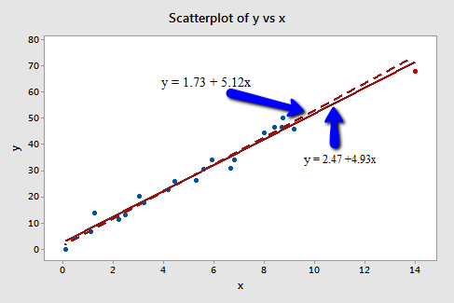
Again, it's hard to even tell the two estimated regression equations apart! The solid line represents the estimated regression equation with the red data point included, while the dashed line represents the estimated regression equation with the red data point taken excluded. The slopes of the two lines are very similar — 4.927 and 5.117, respectively.
Do the two samples yield different results when testing H0: β1 = 0? Well, we obtain the following output when the red data point is included:
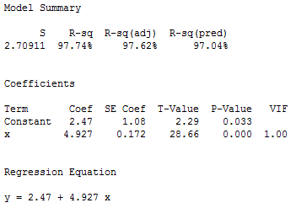
and the following output when the red data point is excluded:
Here, there are hardly any side effects at all from including the red data point:
- The R2 value has hardly changed at all, increasing only slightly from 97.3% to 97.7%. In either case, the relationship between y and x is deemed strong.
- The standard error of b1 is about the same in each case — 0.172 when the red data point is included, and 0.200 when the red data point is excluded. Therefore, the width of the confidence intervals for β1 would largely remain unaffected by the existence of the red data point. You might take note that this is because the data point is not an outlier heavily impacting MSE.
- In each case, the P-value for testing H0: β1 = 0 is less than 0.001. In either case, we can conclude that there is sufficient evidence at the 0.05 level to conclude that, in the population, x is related to y.
In short, the predicted responses, estimated slope coefficients, and hypothesis test results are not affected by the inclusion of the red data point. Therefore, the data point is not deemed influential. In summary, the red data point is not influential, nor is it an outlier, but it does have high leverage.

Example #4
One last example! Do you think the following data set (influence4.txt) contains any outliers? Or, any high leverage data points?
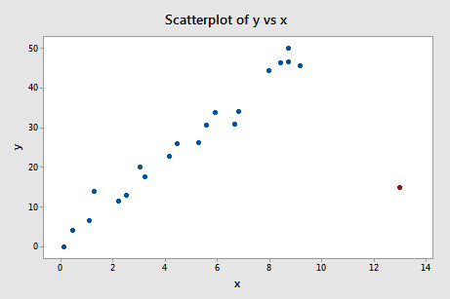
That's right — in this case, the red data point is most certainly an outlier and has high leverage! The red data point does not follow the general trend of the rest of the data and it also has an extreme x value. And, in this case the red data point is influential. The two best fitting lines — one obtained when the red data point is included and one obtained when the red data point is excluded:
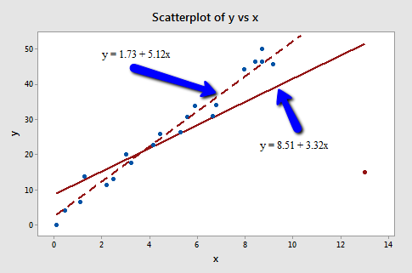
are (not surprisingly) substantially different. The solid line represents the estimated regression equation with the red data point included, while the dashed line represents the estimated regression equation with the red data point taken excluded. The existence of the red data point significantly reduces the slope of the regression line — dropping it from 5.117 to 3.320.
Do the two samples yield different results when testing H0: β1 = 0? Well, we obtain the following output when the red data point is included:
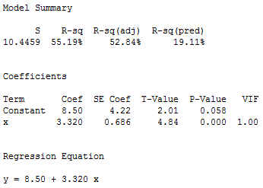
and the following output when the red data point is excluded:
What impact does the red data point have on our regression analysis here? In summary:
- The R2 value has decreased substantially from 97.32% to 55.19%. If we include the red data point, we conclude that the relationship between y and x is only moderately strong, whereas if we exclude the red data point, we conclude that the relationship between y and x is very strong.
- The standard error of b1 is almost 3.5 times larger when the red data point is included — increasing from 0.200 to 0.686. This increase would have a substantial effect on the width of our confidence interval for β1. Again, the increase is because the red data point is an outlier — in the y direction.
- In each case, the P-value for testing H0: β1 = 0 is less than 0.001. In both cases, we can conclude that there is sufficient evidence at the 0.05 level to conclude that, in the population, x is related to y. Note, however, that the t-statistic decreases dramatically from 25.55 to 4.84 upon inclusion of the red data point.
Here, the predicted responses and estimated slope coefficients are clearly affected by the presence of the red data point. While the data point did not affect the significance of the hypothesis test, the t-statistic did change dramatically. In this case, the red data point is deemed both high leverage and an outlier, and it turned out to be influential too.

Summary
The above examples — through the use of simple plots — have highlighted the distinction between outliers and high leverage data points. There were outliers in examples 2 and 4. There were high leverage data points in examples 3 and 4. However, only in example 4 did the data point that was both an outlier and a high leverage point turn out to be influential. That is, not every outlier or high leverage data point strongly influences the regression analysis. It is your job as a regression analyst to always determine if your regression analysis is unduly influenced by one or more data points.
Of course, the easy situation occurs for simple linear regression, when we can rely on simple scatter plots to elucidate matters. Unfortunately, we don't have that luxury in the case of multiple linear regression. In that situation, we have to rely on various measures to help us determine whether a data point is an outlier, high leverage, or both. Once we've identified such points we then need to see if the points are actually influential. We'll learn how to do all this in the next few sections!

